A CRM APPLICATION TO ENGINEERING WORKS

Email: [niranjanbharathi054@gmail.com](mailto:niranjanbharathi054@gmail.com)

Team Members: Niranjan.B, Thirumurugan.D, Pughazendhi.E,Balaji.D

**1.Salesforce developer account creation :**

**\*Creating Developer Account:**

1. Go to<https://developer.salesforce.com/signup>2. On the sign up form, enter the following details :

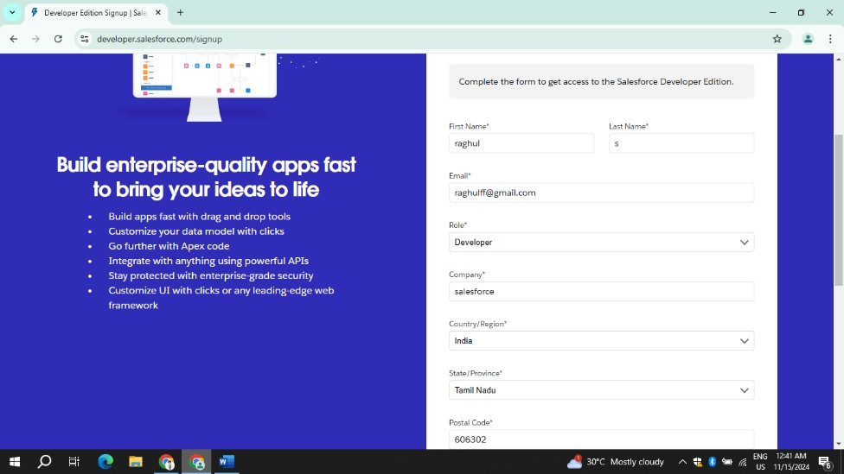

1. First name & Last name
2. Email
3. Role : Developer
4. Company : College or Company Name
5. County : India
6. Postal Code : pin code
7. Username : should be a combination of your name and company This need not be an actual email id, you can give anything in the format :

username@organization.com

Click on sign me up after filling these.

**\*Account Activation:**

1. Go to the inbox of the email that you used while signing up. Click on the verify account to activate your account. The email may take 5-10mins.
2. Click on Verify Account
3. Give a password and answer a security question and click on change password.
4. Give a password and answer a security question and click on change password.

5.

Then you will redirect

to your salesforce setup page.

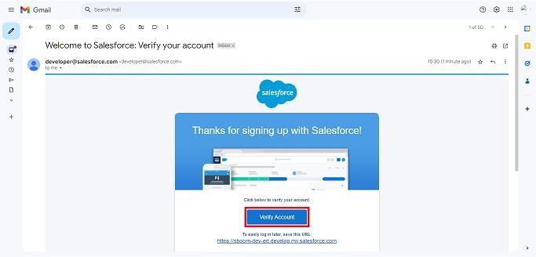

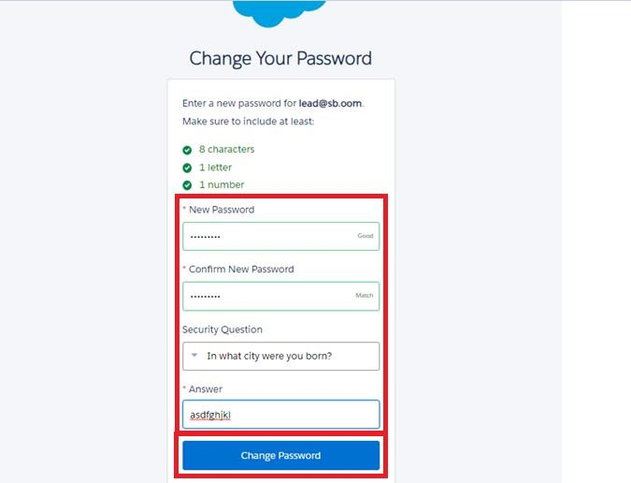

**2.Object:**

1. From the setup page ? Click on Object Manager ? Click on Create ? Click on Custom Object.
2. On Custom object defining page:
3. Enter the label name, plural label name, click on Allow reports, Allow search.
4. Click on Save.

* **Create Fabrication Object:**
  1. From the setup page >> Click on Object Manager >> Click on Create >> Click on Custom Object.
  2. Enter the label name>> Fabrication
  3. Plural label name >> Fabrications
  4. Enter Record Name Label and Format
     + Record Name >> Fabrication Name
     + Data Type >> Text
  5. Click on Allow reports and Track Field History,Allow Activities
  6. Allow search >> Save.
* **Create Shed-Work Object:**
  1. From the setup page >> Click on Object Manager >> Click on Create >> Click on Custom Object.
  2. Enter the label name >> Shed-Work
  3. Plural label name >> Shed Works
  4. Enter Record Name Label and Format
     + Record Name >> Shed Work Name
     + Data Type >> Text
  5. Click on Allow reports and Track Field History,Allow Activities
  6. Allow search >> Save.
* **Create Pipe Lining Object:**
  1. From the setup page >> Click on Object Manager >> Click on Create >> Click on Custom Object.
  2. Enter the label name >> Pipe Lining
  3. Plural label name >> Pipe Linings
  4. Enter Record Name Label and Format
     + Record Name >> Pipe Lining Name
     + Data Type >> Text
  5. Click on Allow reports and Track Field History,Allow Activities
  6. Allow search >> Save.
* **Create Worker Object:**
  1. From the setup page >> Click on Object Manager >> Click on Create >> Click on Custom Object.
  2. Enter the label name >> Worker
  3. Plural label name >> Workers
  4. Enter Record Name Label and Format
     + Record Name >> Worker Name
     + Data Type >> Text
  5. Click on Allow reports and Track Field History,Allow Activities
  6. Allow search >> Save.

**3.Tabs:**

A tab is like a user interface that is used to build records for objects and to view the records in the objects.

* **Creating a Custom Tab:**
  1. Go to setup page >> type Tabs in Quick Find bar >> click on tabs >> New (under custom object tab)

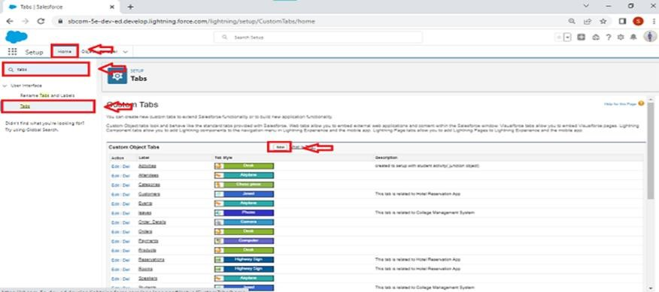

* 1. Select Object(Fabrication) >> Select the tab style >> Next (Add to profiles page) keep it as default >> Next (Add to Custom App) uncheck the include tab .
  2. Make sure that the Append tab to users' existing personal customizations is checked.
  3. Click save

**4.The Lightning App:**

The term **"Lightning App"** generally refers to an app built using **Salesforce Lightning**, a modern, UI (User Interface) framework developed by Salesforce. It's designed to improve the user experience within the Salesforce ecosystem by offering a more responsive, customizable, and mobile-first approach to building and deploying applications.

* **Create a Lightning App:**

1. Go to setup page >> search “app manager” in quick find >> select “app manager” >> click on New lightning App.

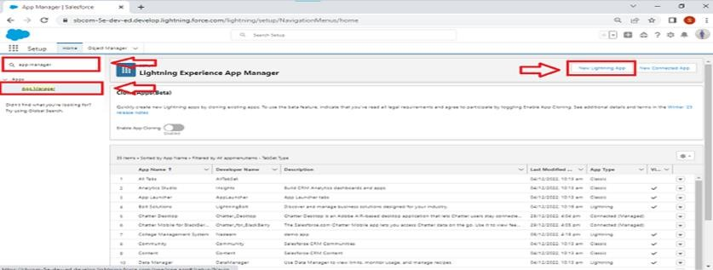

1. Fill the app name in app details and branding as follow

App Name : Engineering Works

Developer Name : This will auto populated

Image : optional (if you want to give any image you can otherwise not mandatory) Primary color hex value : keep this default.

3.Then click Next >> (App option page)Set Navigation Style as Standard Navigation >> Next.

* 1. (Utility Items) keep it as default >> Next.
  2. To Add Navigation Items:

Search for the item in the (Fabrications, Shed Works, Pipe Linings, Workers) from the search bar and move it using the arrow button >> Next >> Next.

* 1. To Add User Profiles:

**5. Fields:**

**Salesforce Lightning Apps**, **fields** refer to individual pieces of data or attributes that are associated with records within the Salesforce platform. Fields are the building blocks of data entry and organization in Salesforce, allowing you to capture and store information about various objects (e.g., Contacts, Accounts, Opportunities).

**\* Creation of fields for the Fabrication:**

1. Go to setup >> click on Object Manager >> type object name(Fabrication) in search bar >> click on the object.

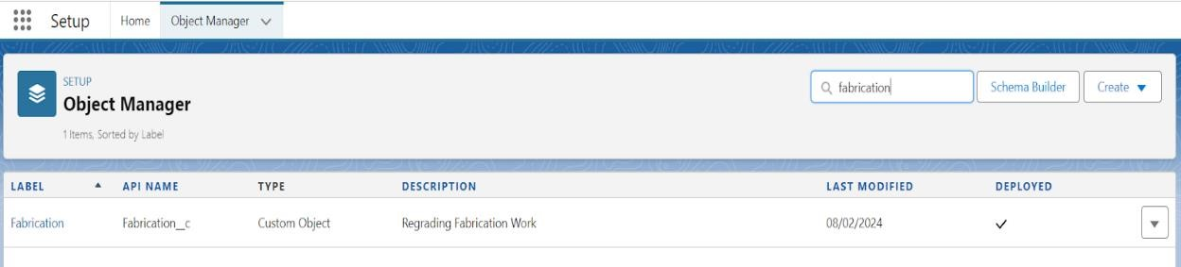

1. Now click on “Fields & Relationships” >> New

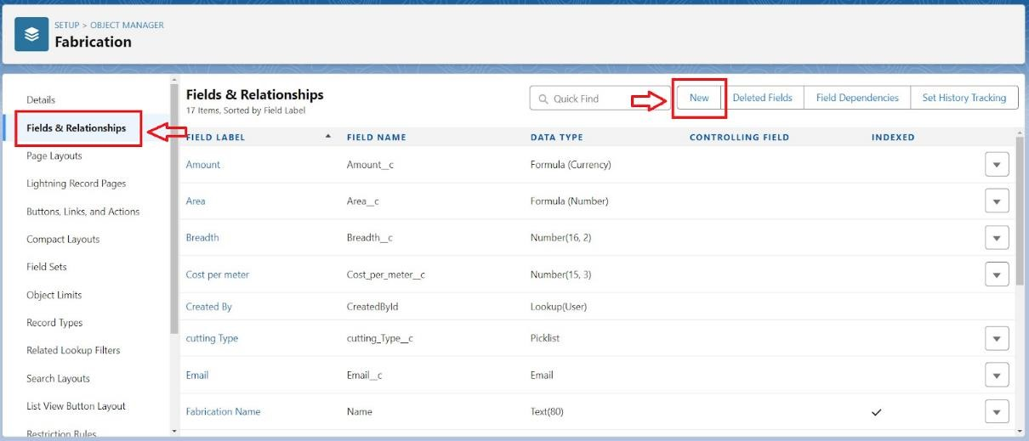

1. Select Data Type as a “Text”
2. Click on next
3. . Fill the Above as following
   * Field Label: Name of the Owner
   * Field Name : Name_of_the_Owner
   * Length : 125
   * Required :check box
   * Click on Next >> Next >> Save and new.

**\* fields for the Shed-Work:**

.Go to setup >> click on Object Manager >> type object name(Shed-Work) in search bar >> click on the object.

1. Now click on “Fields & Relationships” >> New
2. Select Data type as a “Text” and Click on Next
3. Fill the Above as following:
   * Field Label : Name of the Company
   * Field Name : gets auto generated
   * Click on required check box
   * Click on Next >> Next >> Save and new.

To create another fields in an object:

1. Go to setup >> click on Object Manager >> type object name(Shed-Work) in search bar >> click on the object.
2. Now click on “Fields & Relationships” >> New
3. Select Data type as a “Text” and Click on Next 4. Fill the Above as following:
   * Field Label : Name of the Owner
   * Field Name : Name_of_Owner
   * Click on required check box
   * Click on Next >> Next >> Save and new.

To create another fields in an object:

1. Go to setup >> click on Object Manager >> type object name(Shed-Work) in search bar >> click on the object.
2. Now click on “Fields & Relationships” >> New
3. Select Data type as a “Number” and Click on Next
4. Fill the Above as following:
   * Field Label: Height
   * Field Name : Height
   * Length : 16
   * Decimal Value : 2
   * Required :check box
   * Click on Next >> Next >> Save and new.

* **fields for the Pipe Lining:**

Go to setup >> click on Object Manager >> type object name(Pipe Lining) in search bar >> click on the object.

1. Now click on “Fields & Relationships” >> New
2. Select Data type as a “Text” and Click on Next
3. Fill the Above as following:
   * Field Label : Name of the Company
   * Field Name : gets auto generated
   * Click on required check box
   * Click on Next >> Next >> Save and new.

To create another fields in an object:

1. Go to setup >> click on Object Manager >> type object name(Pipe Lining) in search bar >> click on the object.
2. Now click on “Fields & Relationships” >> New
3. Select Data type as a “Text” and Click on Next 4. Fill the Above as following:
   * Field Label : Name of the Owner
   * Field Name : Name_of_Owner
   * Click on required check box
   * Click on Next >> Next >> Save and new.

To create another fields in an object:

1. Go to setup >> click on Object Manager >> type object name(Pipe Lining) in search bar >> click on the object.
2. Now click on “Fields & Relationships” >> New 7. Select Data type as a “Number” and Click on Next
3. Fill the Above as following:
   * Field Label: Height
   * Field Name : Height
   * Length : 16
   * Decimal Value : 2
   * Required :check box
   * Click on Next >> Next >> Save and new.

To create another fields in an object:

1. Go to setup >> click on Object Manager >> type object name(Pipe Lining) in search bar >> click on the object.
2. Now click on “Fields & Relationships” >> New
3. Select Data type as a “Number” and Click on Next 12. Fill the Above as following:
   * Field Label: Width
   * Field Name : Width
   * Length : 16
   * Decimal Value : 2
   * Required :check box
   * Click on Next >> Next >> Save and new.

**\* fields for the Worker object:**

Go to setup >> click on Object Manager >> type object name(Worker) in search bar >> click on the object.

1. Now click on “Fields & Relationships” >> New
2. Select Data type as a “Text” and Click on Next
3. Fill the Above as following:
   * Field Label : Worker Name
   * Field Name : gets auto generated
   * Length : 125
   * Click on Next >> Next >> Save and new.

To create another fields in an object:

1. Go to setup >> click on Object Manager >> type object name(Worker) in search bar >> click on the object.
2. Now click on “Fields & Relationships” >> New
3. Select Data type as a “Number” and Click on Next
4. Fill the Above as following:
   * Field Label: Phone Number
   * Field Name : Phone_Number
   * Length : 10
   * Required :check box
   * Click on Next >> Next >> Save and new.

To create another fields in an object:

1. Go to setup >> click on Object Manager >> type object name(Worker) in search bar >> click on the object.
2. Now click on “Fields & Relationships” >> New
3. Select Data type as a “Picklist” and Click on Next
4. Fill the Above as following: • Field Label: Designation
   * Field Name : Designation
   * Values : Select Enter values, with each value separated by a new line • Enter this values in box :

Accountant

Welder

Driller

Pitter

Manager

* + Click on Next >> Next >> Save and new.
* **Lookup fields:**
  1. Go to setup>> click on Object Manager >> type object name(Worker) in the search bar >> click on the object.

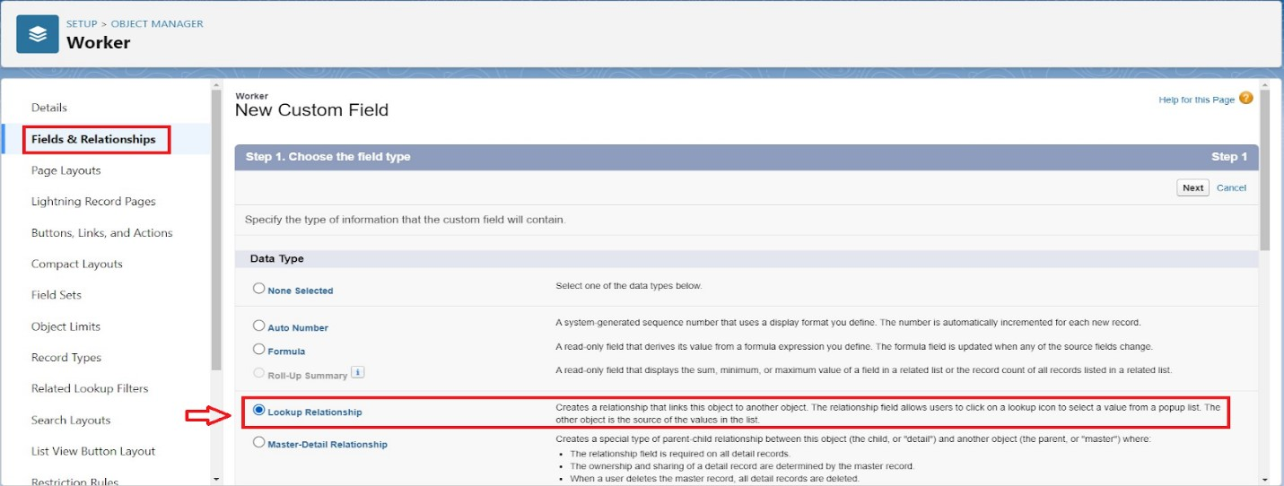

* 1. Now click on “Fields & Relationships” >> New
  2. Select lookup relationship
  3. Select the related object “Fabrication” and click next.
  4. Field Name : Fabrication
  5. Field label : Auto generated
  6. Next >> Next >> Save.

**6.Creation of Page Layouts:**

Here we have to create Four Page Layouts (For Drilling, For Welding, For Cutting, For Folding)

* **Fabrication Object for Drilling:**

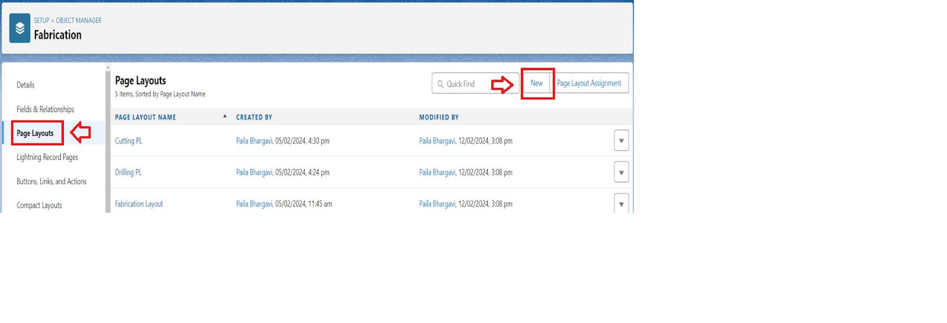

* 1. Go to the setup page >> click on object manager >> From drop down click edit for Fabrication object.
  2. Click on the Page Layouts >> click New.
  3. Enter details as
     + Page Layout Name : Drilling Page Layout
     + Click on Save

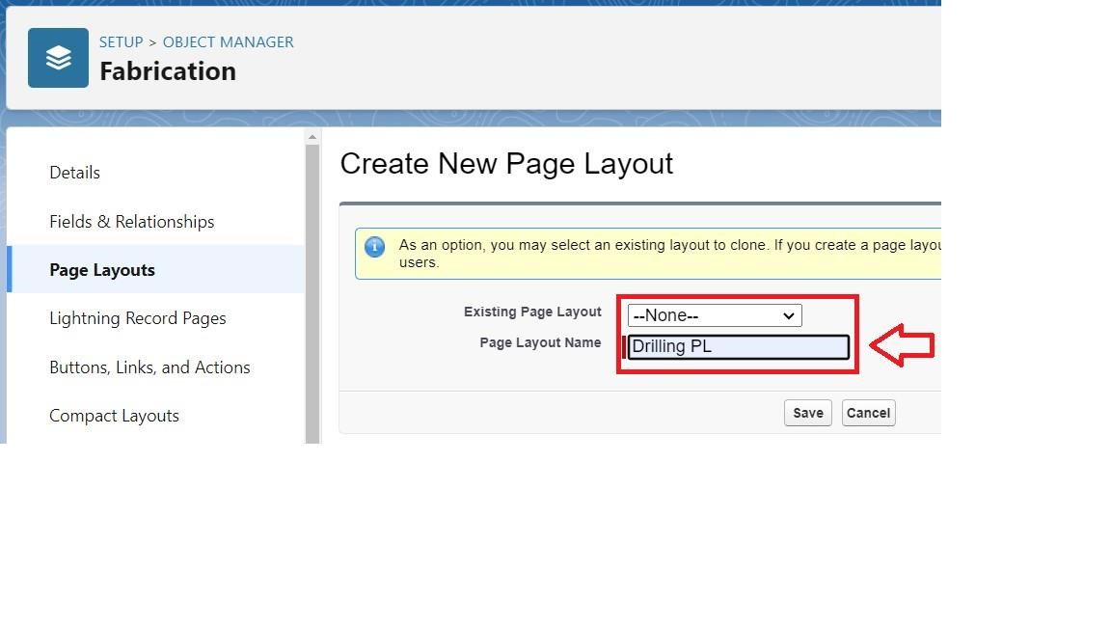

1. Drag and Arrange the field as shown below
2. Click Save.

* **Fabrication Object for Welding:**

1. Go to the setup page >> click on object manager >> From drop down click edit for Fabrication object.
2. Click on the Page Layouts >> click New.
3. Enter details as
   * Page Layout Name : Welding Page Layout
   * Click on Save
4. Drag and Arrange the field as shown below

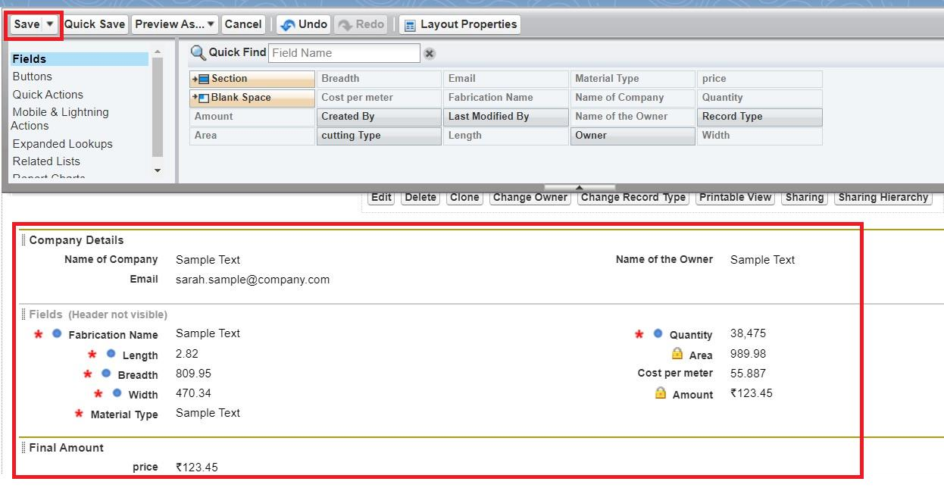

1. Click Save.

* **Fabrication Object for Cutting:**

1. Go to the setup page >> click on object manager >> From drop down click edit for Fabrication object.
2. Click on the Page Layouts >> click New.
3. Enter details as
   * Page Layout Name : Cutting Page Layout
   * Click on Save
4. Drag and Arrange the field as shown below

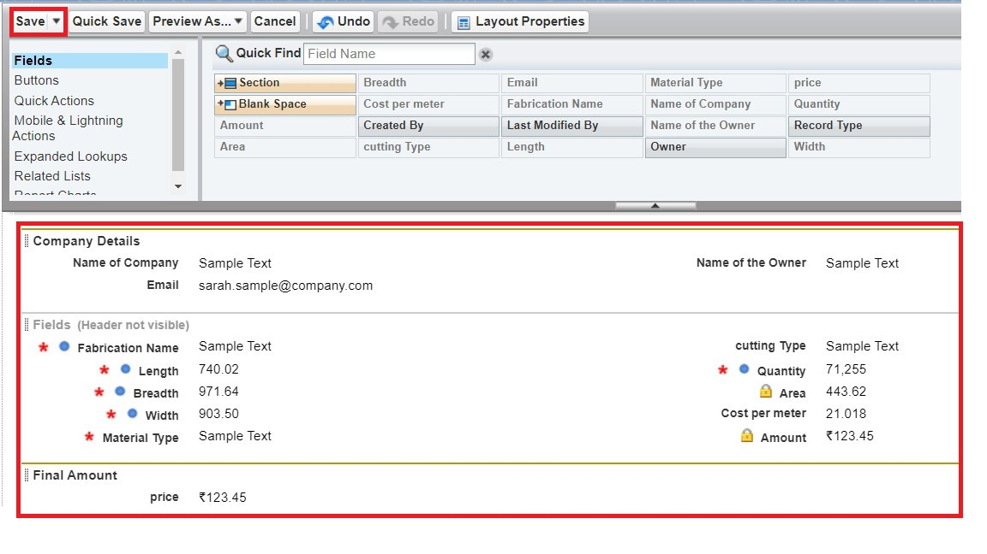

1. Click Save.

**\* Fabrication Object for Folding:**

1. Go to the setup page >> click on object manager >> From drop down click edit for Fabrication object.
2. Click on the Page Layouts >> click New.
3. Enter details as
   * Page Layout Name : Folding Page Layout
   * Click on Save

4. Drag and Arrange the field as shown below

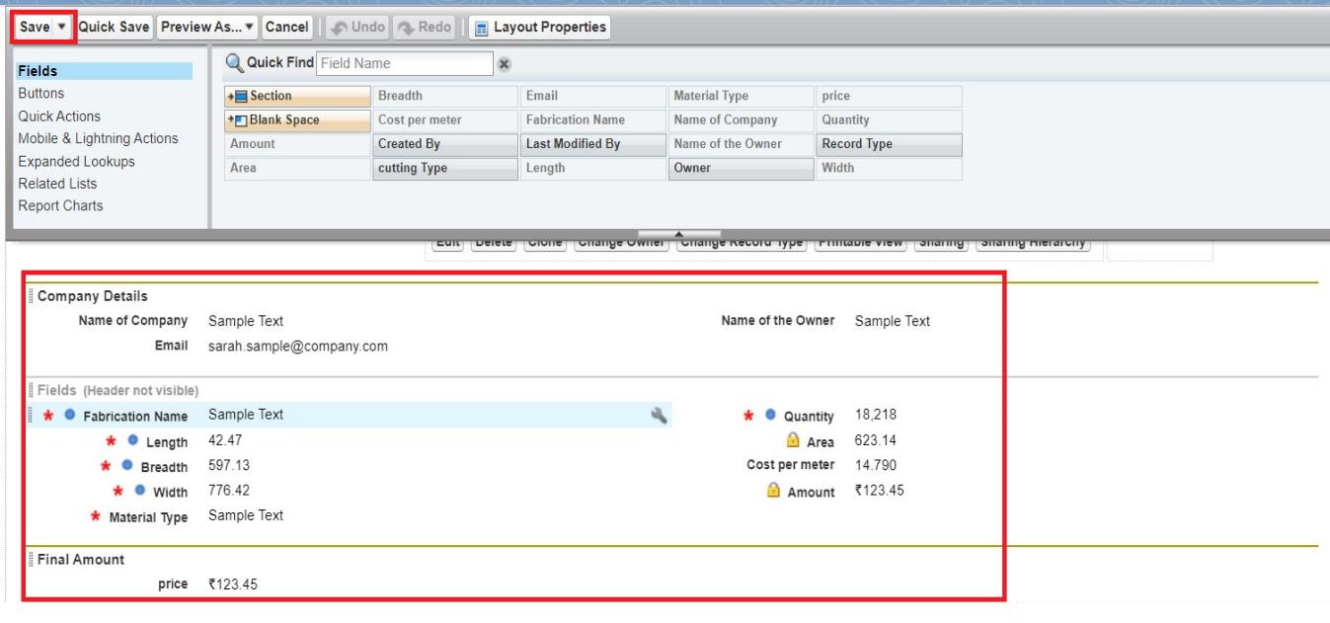

1. Click Save

**7. Creation of Record Types:**

For the Fabrication Object we have to create 4 Record Types (Drilling, Welding, Cutting, Folding)

* **Record Types in Fabrication:**

1. Go to the setup page >> click on object manager >> From drop down click edit for Fabrication object.
2. Click on the Record Types >> click New.

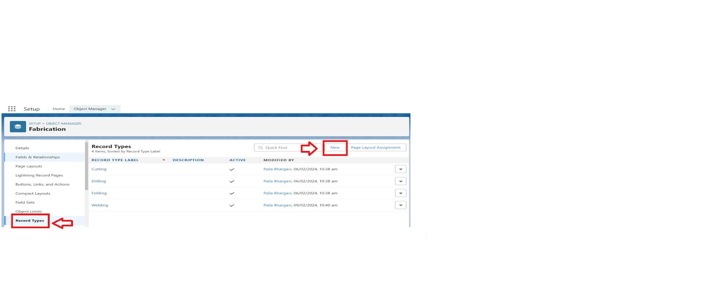

1. Enter the details : For Record Types
   * Existing Record Types : Master
   * Record Type Label : Drilling
   * Record Type Name : Drilling
   * Active : Tick checkbox
2. Click on Next
3. In Assign Page Layout

• Apply one layout to all profiles : Select Drilling Page Layout

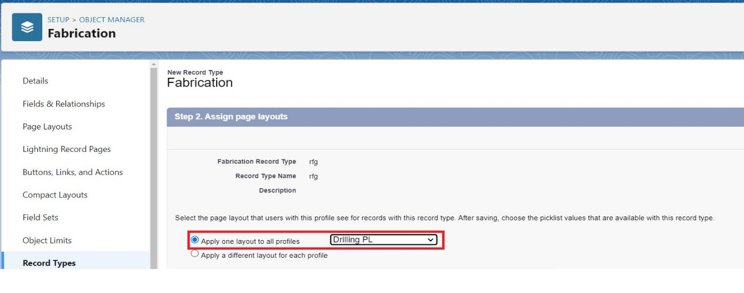

1. Click on Save

**8. Validation rule:**

A **Validation Rule** in Salesforce is a powerful feature that ensures data entered into the system meets specific criteria or business rules. Validation rules are used to prevent users from saving a record if certain conditions aren't met. This is helpful for maintaining data integrity and ensuring that the data entered into Salesforce is accurate, complete, and consistent

\***validation rule to an Fabrication :**

* 1. Go to the setup page >> click on object manager >> From drop down click edit for Fabrication object.
  2. Click on the validation rule >> click New.

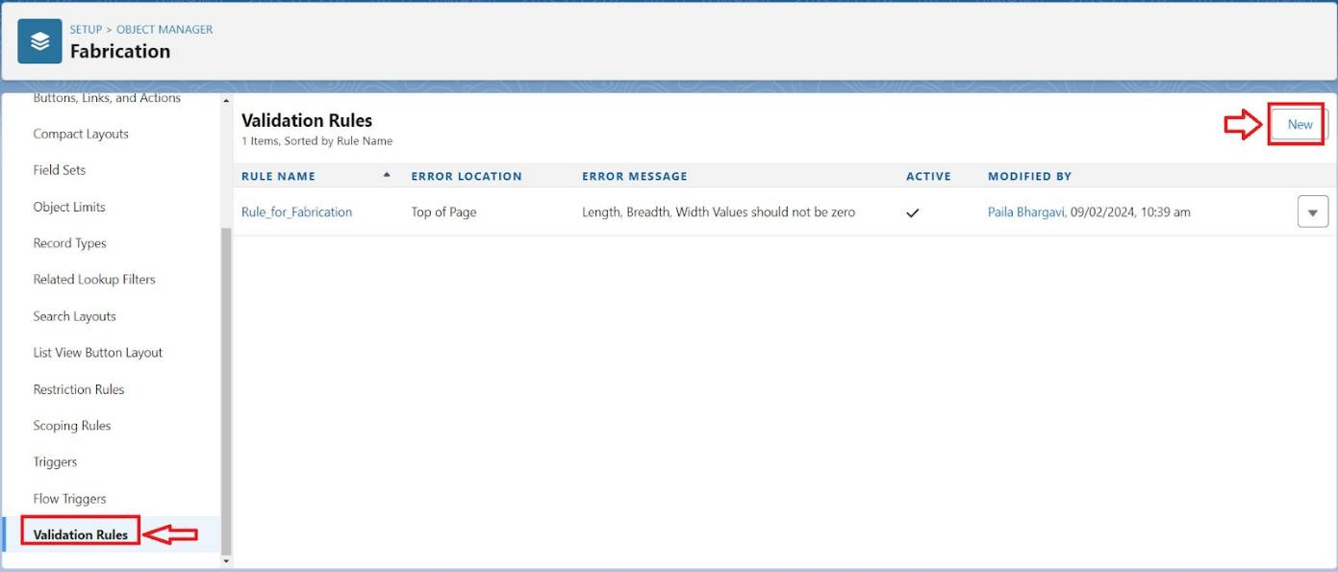

* 1. Enter the Rule name as “Rule_for_fabrication”.
  2. Insert the Error Condition Formula as :

OR( Length__c == 0, Breadth__c == 0, Width__c ==0, Quantity == 0)

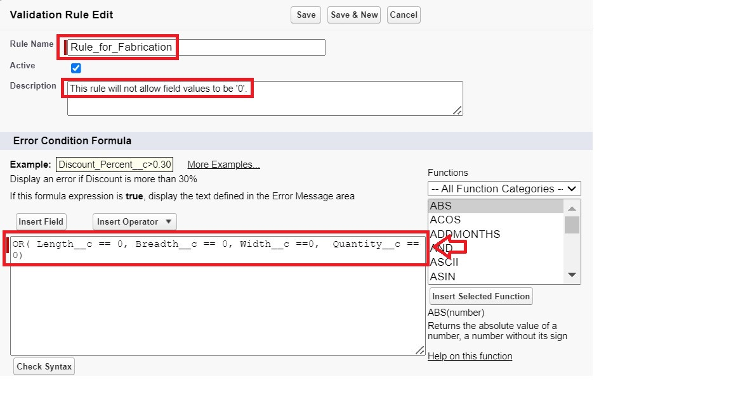

* 1. Enter the Error Message as “Length, Breadth, Width and Quantity Values should not be zero”, select the Error location as Top of Page and click Save.

**9.Email Templates:**

Here are some email templates for a variety of common scenarios. You can customize them to suit your specific needs.

**\*Upload Logo into Salesforce:**

* 1. Go to the setup page >> In quick find box search for Salesforce Branding >> Click on Edit.
  2. In Loading Page Logo >> Choose File >> Select the image and click open >> Click on Save.

**\*Creation of Letterhead:**

* 1. Go to the setup page >> In quick find box search for Classic Letterheads >> Click on New Letterhead.
  2. Check Available for use box.
  3. Letterhead Label : Letterhead for Email Purpose
  4. Letterhead Unique Name : Auto-populated
  5. Click on Save >> Now click on Letterhead for Email Purpose then Edit Letterhead.
  6. Click on select logo >> Now select the logo and click save.

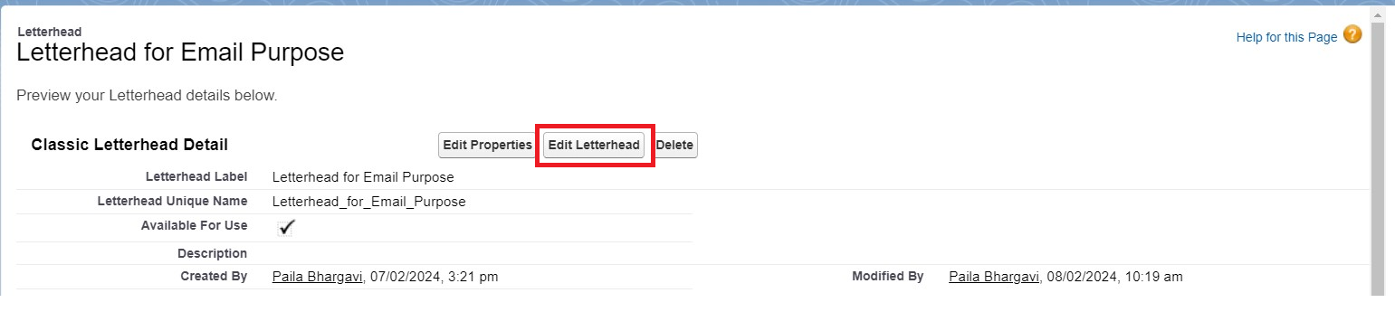

* **Create Email Template:**

Go to setup in quick find box enter email template >> click on classic Email Template.

* 1. Click on >> New Email Template===>HTML (using Classic Letterhead) Folder : Unfiled public Classic Email templates

Click on available for use

* 1. Email Template Name is “Bill Template”
  2. Template Unique Name : Auto populated
  3. Subject : “Fabrication Template”
  4. Email body : Hello

{!Fabrication__c.Name_of_the_Owner__c}{!Shed_Work__c.Name_of_the_Owner__c}{!Pipe_Lining__c.N ame_of_Owner__c} ,

I hope everything is going well in {!Fabrication__c.Name_of_Company__c}

{!Shed_Work__c.Name_of_Company__c}{!Pipe_Lining__c.Name_of_Company__c} Company. I have been attached the required items for the work to be done. Please verify them.

length = {!Fabrication__c.Length__c}{!Shed_Work__c.Height__c}{!Pipe_Lining__c.Height__c}, breadth

= {!Fabrication__c.Length__c}{!Shed_Work__c.Breadth__c}, width =

{!Fabrication__c.Width__c}{!Shed_Work__c.Width__c}{!Pipe_Lining__c.Width__c}, area = {!Fabrication__c.Area__c}{!Shed_Work__c.Area__c}{!Pipe_Lining__c.Area__c}, The Final Price = {!Fabrication__c.price__c}{!Shed_Work__c.Price__c}{!Pipe_Lining__c.Price__c}.

**\*Create Email Alert:**

* 1. Go to setup in quick find box enter email Alert >> New Email Alert
  2. Description : Email Alert for Fabrication Object

Unique Name : Auto-Populated

Object : Fabrication

Email Template : select the template that is for fabrication Object

Recipients : User: Integration User, User : System Administrator, user : Security User

* 1. Click Save

Similarly create for Pipe-Lining and Shed-Work objects

**10.FLOWS:**

Email flows (or email sequences) are a series of automated or scheduled emails that guide a recipient through a particular journey. These are commonly used in marketing, sales, onboarding, and customer service to nurture relationships, promote engagement, or resolve issues. Below are examples of different types of **email flows** you can set up for various purposes.

* **Create Flow to calculate Final Price :**
  1. Go to setup >> type Flow in quick find box >> Click on the Flow and Select the New Flow.
  2. Select the record Triggered flow.Click on create.
  3. Under Object select ”Fabrication”. Click on A record is created or updated.
  4. Set Entry Conditions : None
  5. Select Actions and Related Records
  6. Under record trigger flow click on “+” icon and select Send Email Alert.
  7. n New Action Select Fabrication Template.
  8. Label : Mail
  9. API Name : Mail 10. Record ID : {!$Record.Id}

1. Click Done.
2. Under record trigger flow click on “+” icon and select Decision For New Decision :
   * Label : Material
   * Api Name : Material For Outcome Details :
   * Label : Iron Material
   * Outcome API Name : Iron_Material
   * Condition Requirements to Execute Outcome : Condition Requirements to Execute Outcome
   * Resource : {!$Record.Material_Type__c}
   * Operator : Equals

**\* Flow Shed Work:**

1. Go to setup >> type Flow in quick find box >> Click on the Flow and Select the New Flow.
2. Select the record Triggered flow.Click on create.
3. Under Object select “Shed Work”. Click on A record is created or updated.
4. Set Entry Conditions : None
5. Select Actions and Related Records
6. Under record trigger flow click on “+” icon and select Send Email Alert.
7. n New Action Select Fabrication Template.
8. Label : Mail
9. API Name : Mail 10. Record ID : {!$Record.Id}
10. lick Done.
11. Under record trigger flow click on “+” icon and select Decision For New Decision :
    * Label : Material
    * Api Name : Material For Outcome Details :
    * Label : Iron Material
    * Outcome API Name : Iron_Material
    * Condition Requirements to Execute Outcome : Condition Requirements to Execute Outcome
    * Resource : {!$Record.Material_Type__c}
    * Operator : Equals

**\*Flow Pipe Lining:**

1. Go to setup >> type Flow in quick find box >> Click on the Flow and Select the New Flow.
2. Select the record Triggered flow.Click on create
3. Under Object select “Pipe Lining”. Click on A record is created or updated.
4. 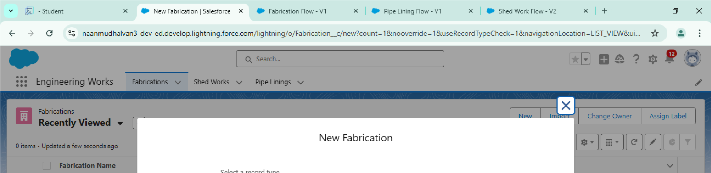Set Entry Conditions : None
5. Select Actions and Related Records

18.Under record trigger flow click on “+” icon and select Send Email

19. Under record trigger flow click on “+” icon and select Decision For New Decision :

* Label : Material
* Api Name : Material For Outcome Details :
* Label : Iron Material
* Outcome API Name : Iron_Material
* Condition Requirements to Execute Outcome : Condition Requirements to Execute Outcome
* Resource : {!$Record.Material_Type__c}
* Operator : Equals
* Value : Iron

**Output:**

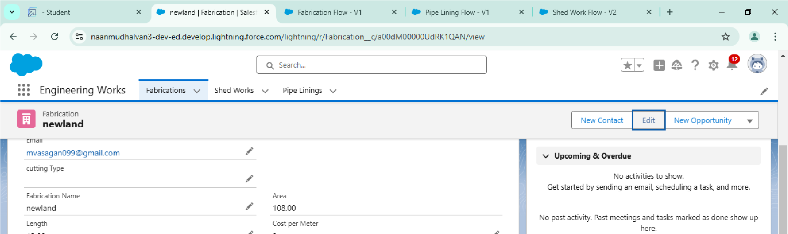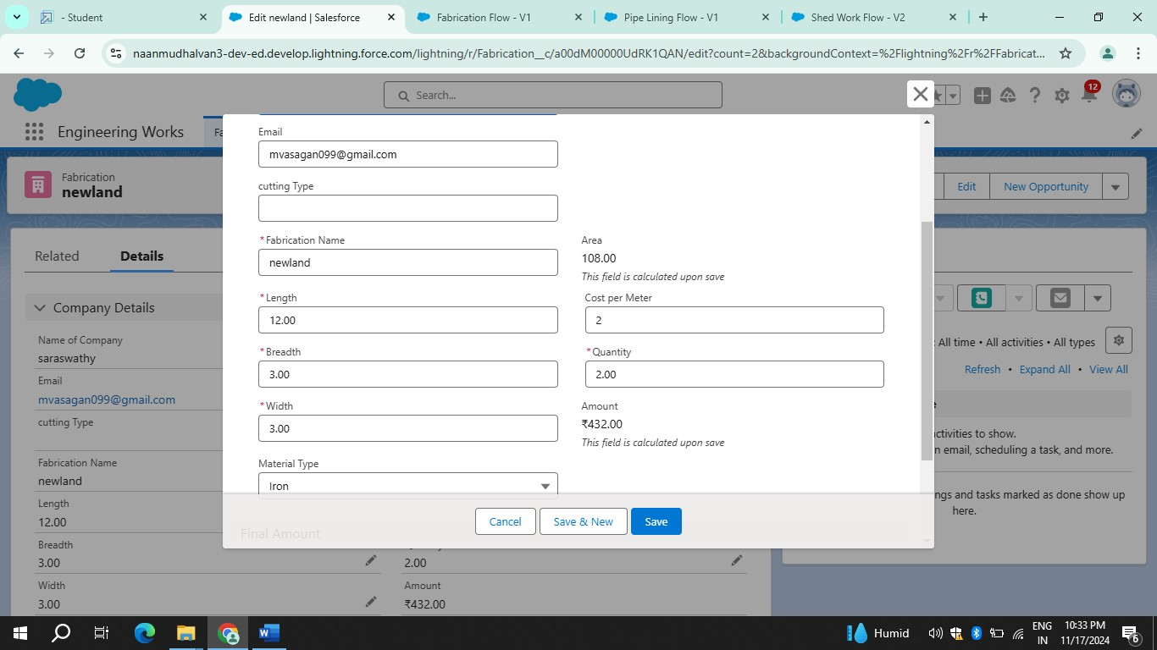

**11. Conclusion:**

This Engineering Works Project automates the calculation of area whenever a record is created or updated, utilizing parameters such as length, breadth, and width, as well as quantity and cost per meter. The final amount is then determined based on the area and material type.